High-Level Summary
The scope of this engagement was to assess the security of the Belt Exam virtual machine (VM) with the IP address 10.0.2.28. The objective was to identify and exploit vulnerabilities, gain access to the system, and ultimately retrieve the flag located in the root/administrator's desktop directory.

Methodologies
I employed a combination of reconnaissance, enumeration, and penetration testing techniques during the engagement to achieve the goals.

Information Gathering
The information gathering phase involved identifying the target system's IP address, which was determined to be 10.0.2.28, using the netdiscover command.
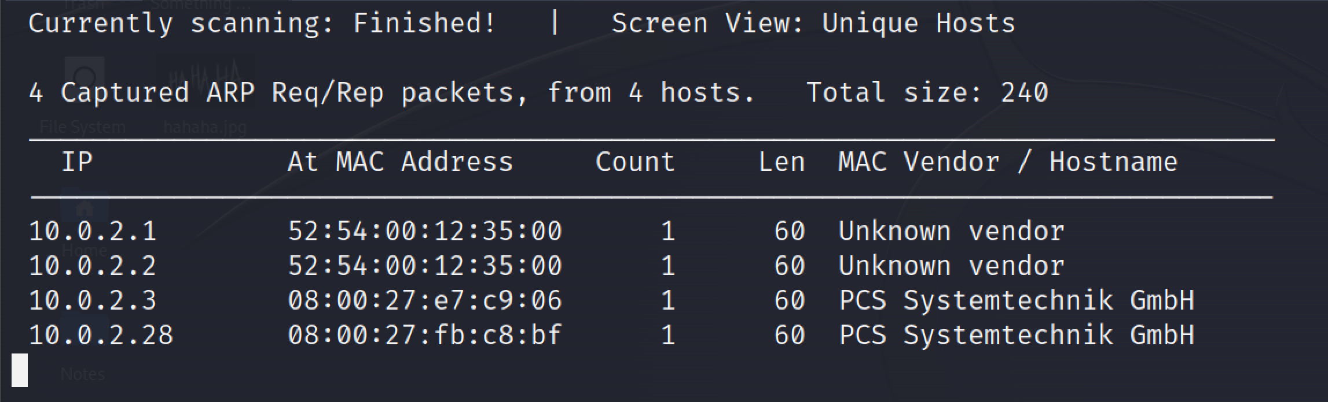

Enumeration
I conducted an aggressive enumeration of the target VM using the nmap tool with the following command: nmap -sV -O -A -p- 10.0.2.28
This scan revealed multiple open ports and services running on the target system, with port 80 being the initial focus of the assessment.
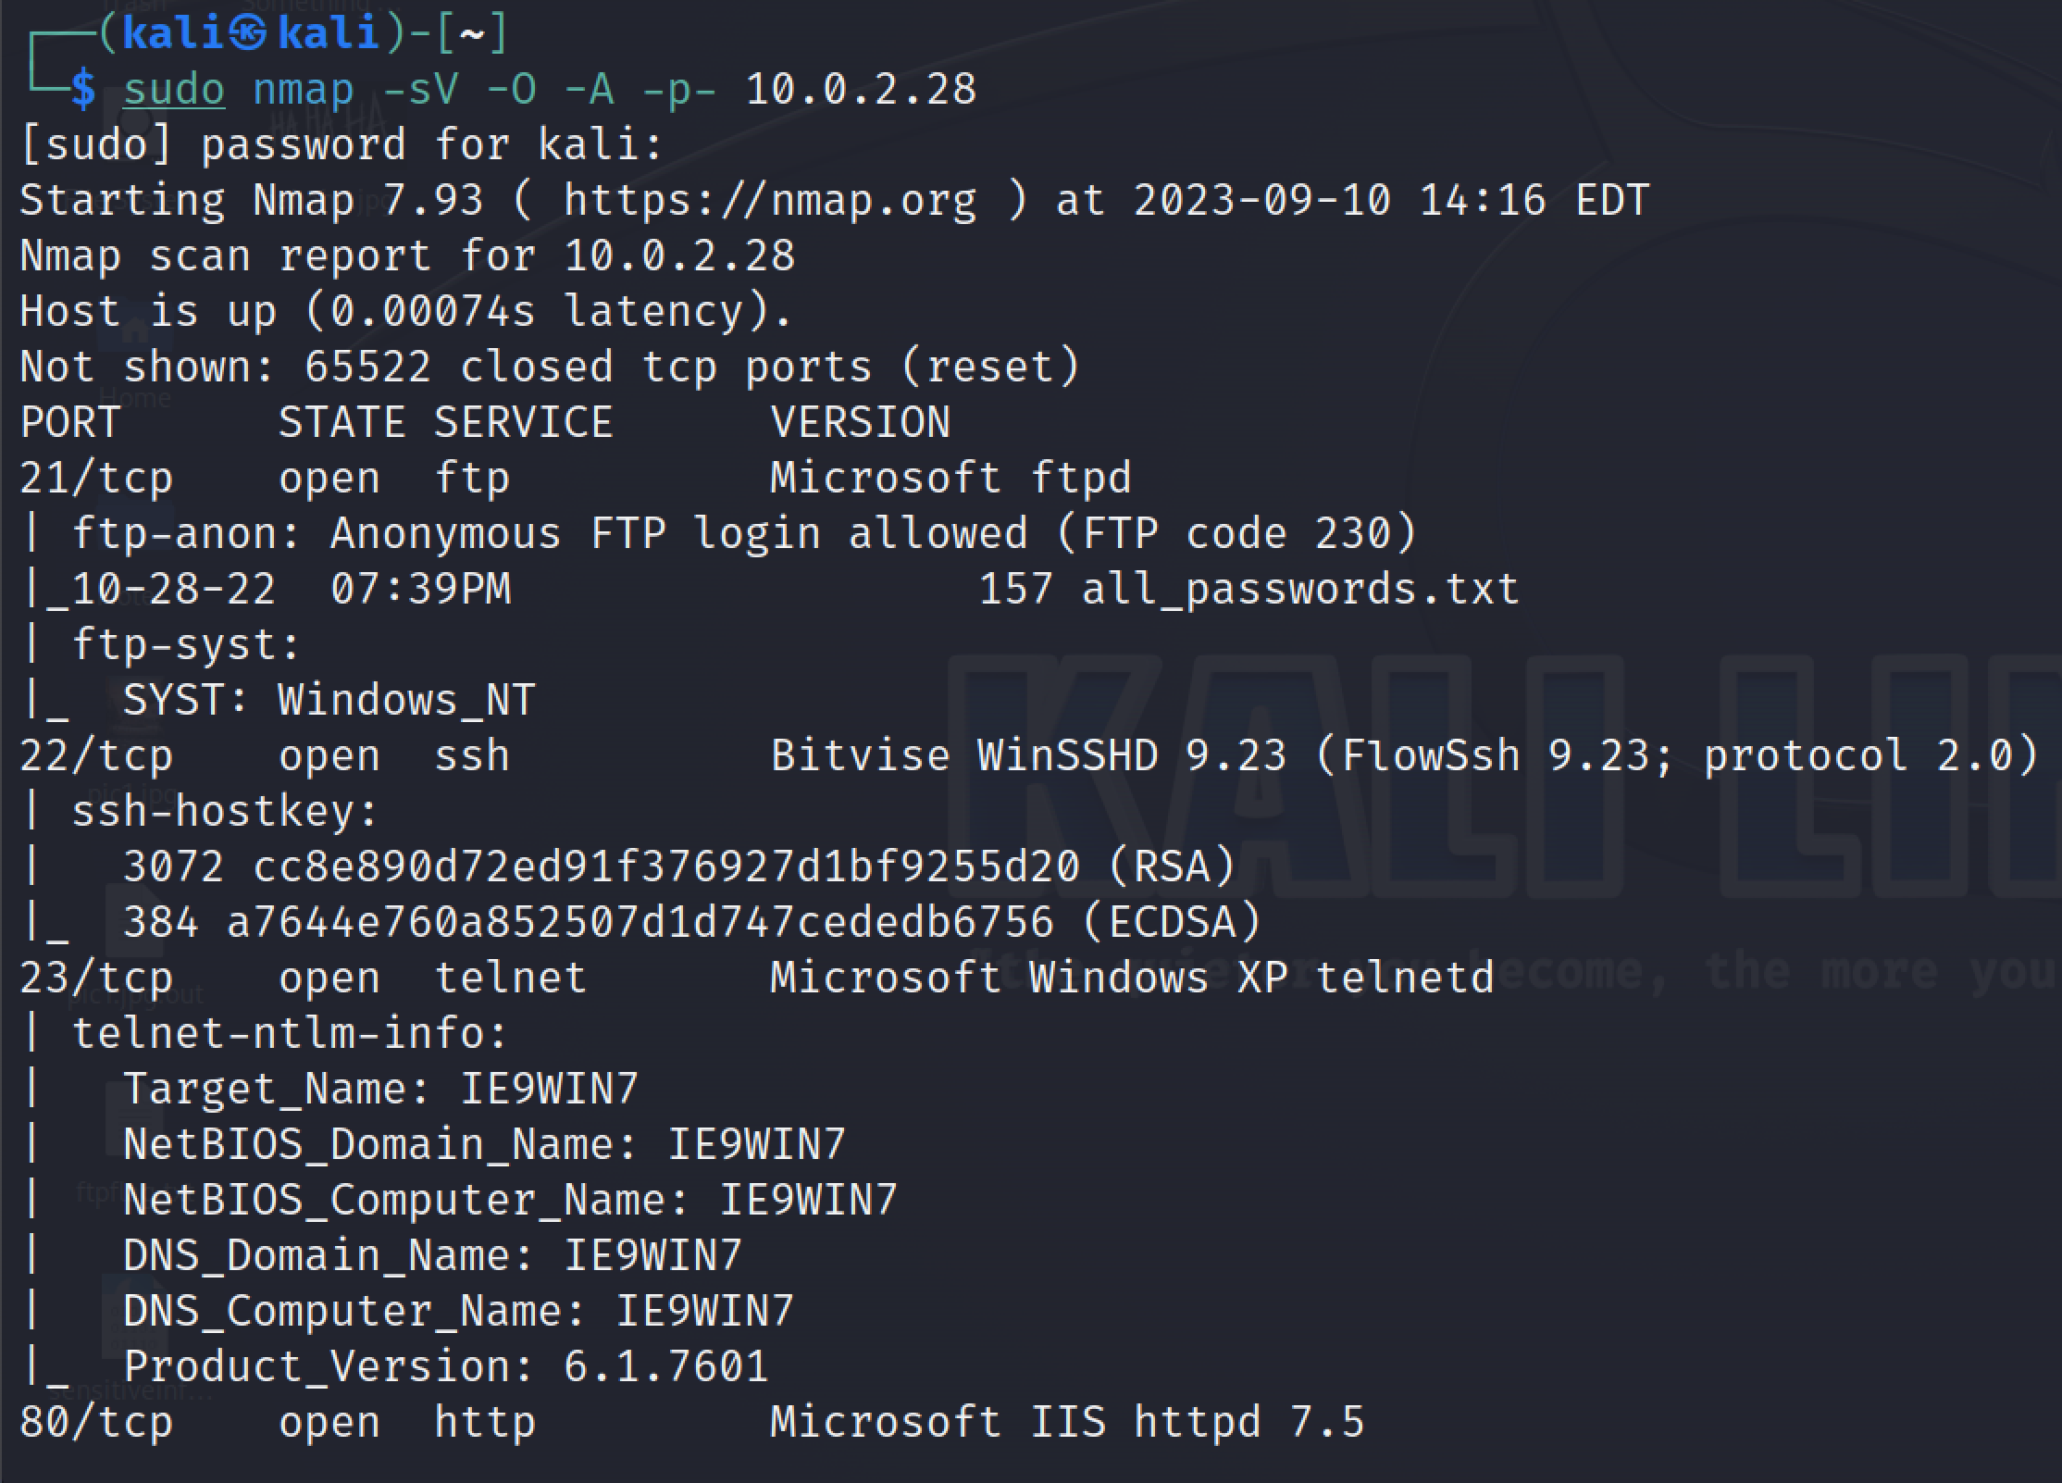

Penetration
To exploit the target system, I followed these steps:
- Accessing the Web Server: I navigated to http://10.0.2.28:80 in Firefox and identified an image on the webpage.


- Steganography Analysis: Suspecting steganography, I saved the image to my desktop and used the stegcracker tool in the terminal to extract hidden data from the image.
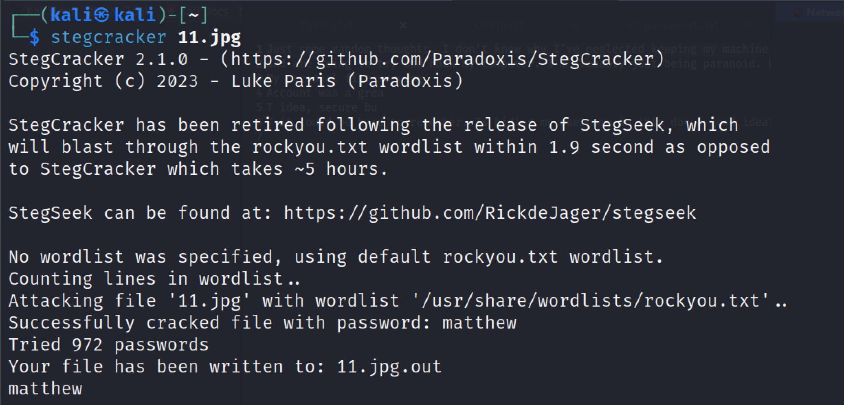
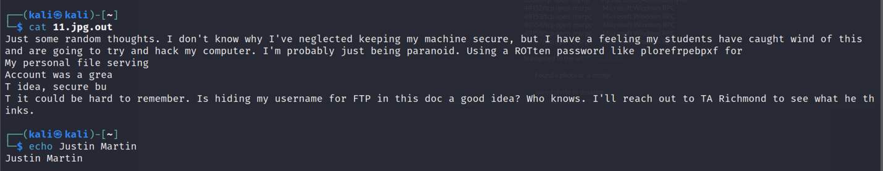

- Deciphering the Hidden Message: The hidden message contained FTP credentials. I decrypted the ROT13-encoded password to access the FTP server.
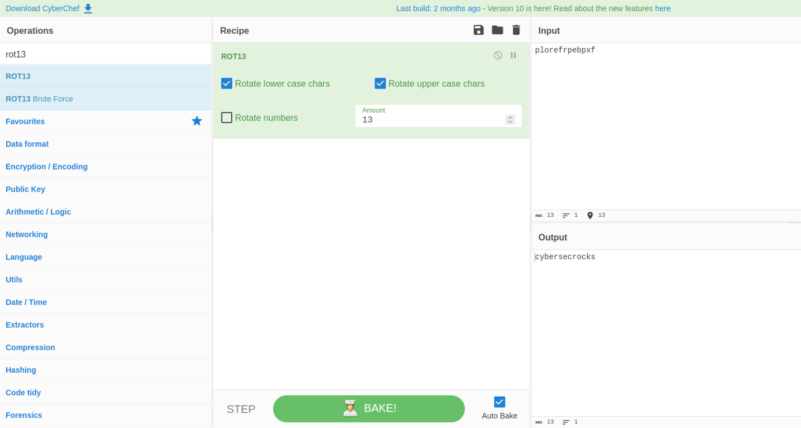

- Accessing FTP and Retrieving Files: With the FTP credentials ('Matt' as the username and 'cybersecrocks' as the password), I logged into the FTP server and retrieved files, including 'ftpflag.txt' and 'sensitiveinfo.pcap.'
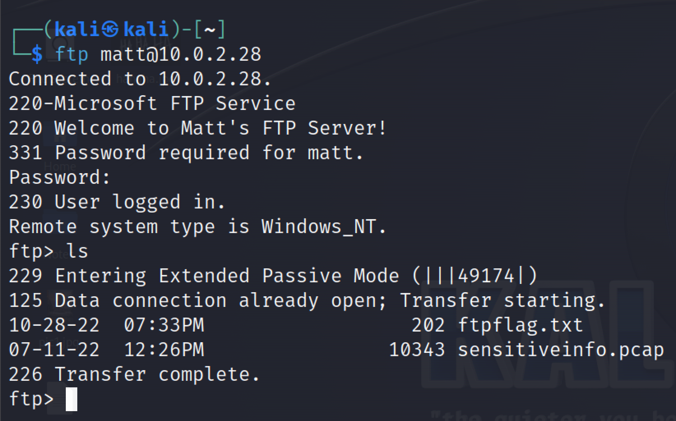

- Analyzing PCAP File: I opened the 'sensitiveinfo.pcap' file using Wireshark and followed the TCP stream, revealing a letter with more clues, including information about an SSH account created by Richmond and a hint about using the Hydra tool.
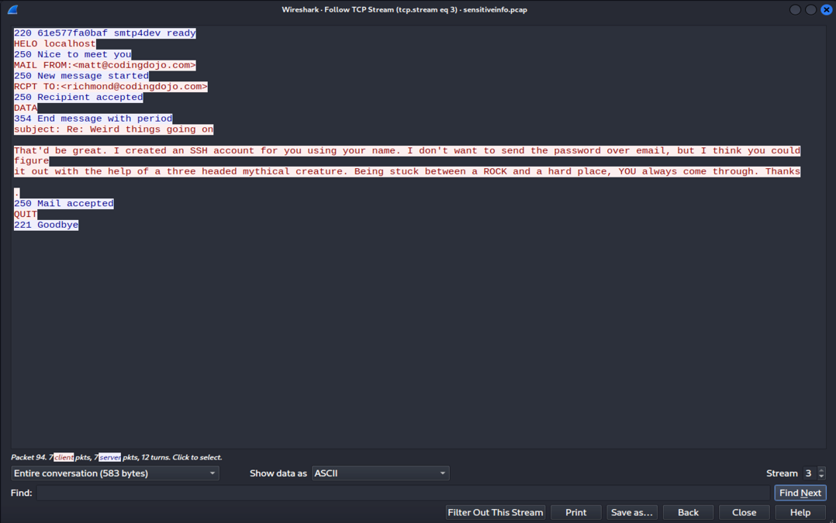

- Using Hydra to Gain SSH Access: I initiated an SSH brute-force attack using the Hydra tool and successfully obtained SSH credentials ('Richmond' as the username and 'password' as the password).
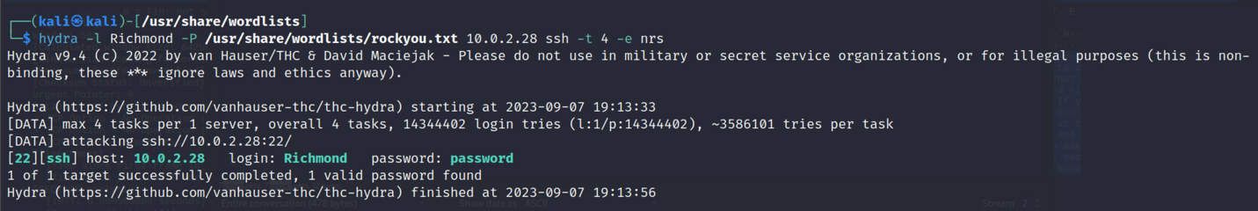

- Accessing SSH and Gathering More Information: I used these credentials to log in via SSH and discovered the 'noteToRichmond.txt' file, which provided additional clues for the exam objectives.
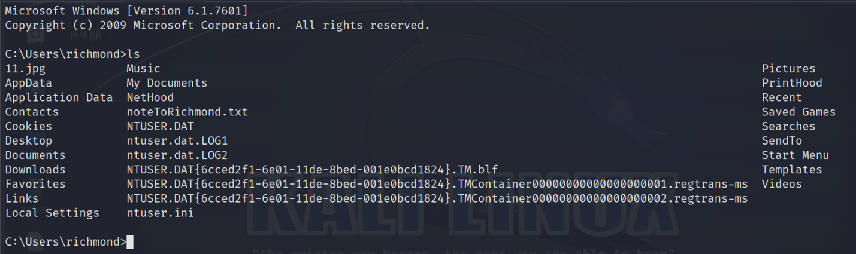
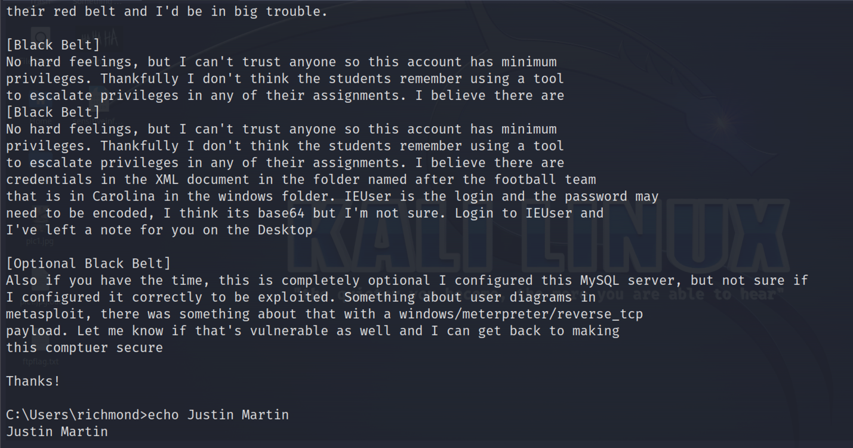

- Gaining a Reverse Shell with Metasploit: Following the instructions for achieving a Red Belt, I crafted a Metasploit payload and used SCP to transfer it to the VM. After setting up a listener and executing the payload, I successfully created a Meterpreter shell, fulfilling the Red Belt objective.
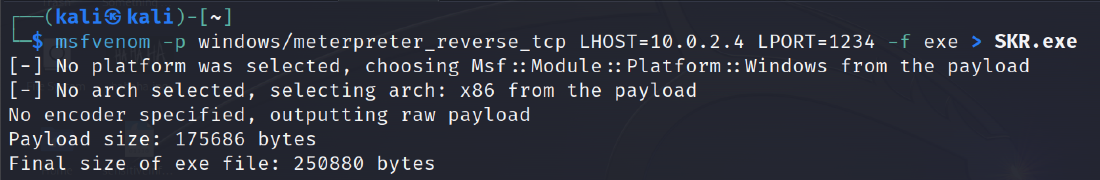
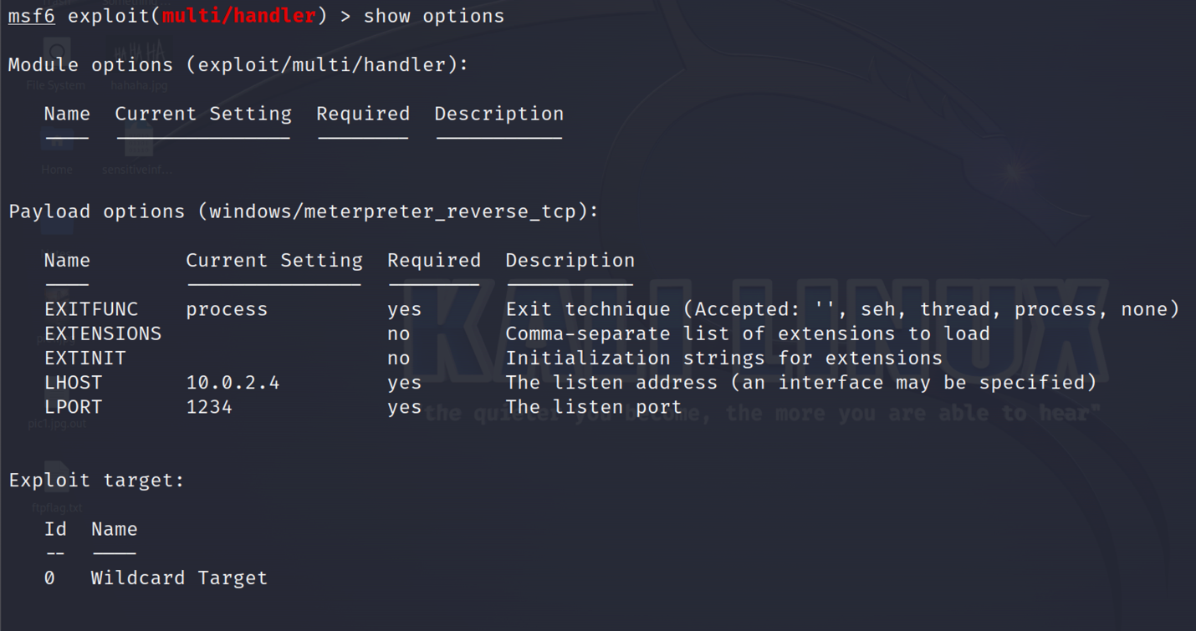
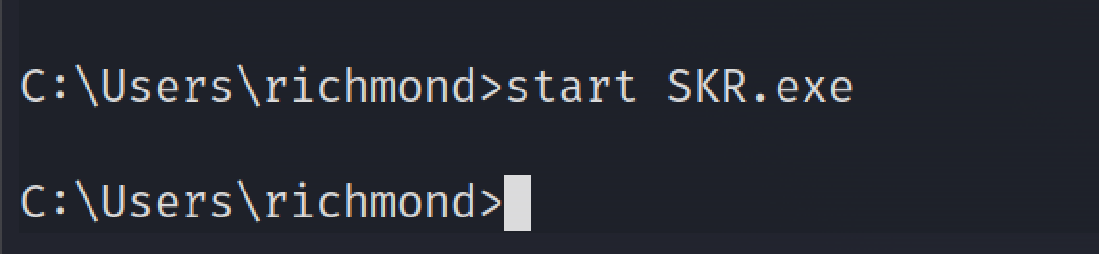
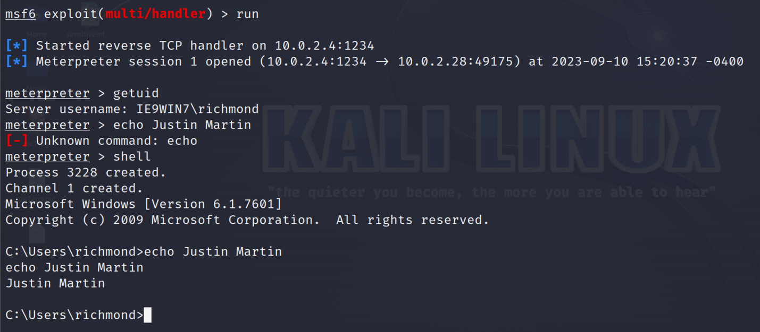

House Cleaning
After successfully completing the assessment, I took the following steps to ensure the system was left fully intact and functional:
- Reverse Exploits: I ensured that any reverse shell or exploit I used during the assessment was terminated, leaving the system in its original state.

Recommendations/Mitigation
To prevent unauthorized access to the system and similar exploits, the following recommendations and mitigation measures should be implemented:
- Patch and Update: Regularly apply security patches and updates to the operating system and all installed software to address known vulnerabilities.
- Firewall Configuration: Configure a firewall to restrict access to unnecessary ports and services. Only essential services should be exposed to the network.
- Steganography Awareness: Employ steganography detection tools and regularly scan image files for hidden data.
- Access Controls: Implement strong password policies, multi-factor authentication, and least privilege access to limit the potential for unauthorized access.
- Password Complexity: Enforce strong password policies and encourage users to choose complex passwords that are less susceptible to brute-force attacks.
- Password Rotation: Require regular password changes to mitigate the risk of passwords being compromised over time.
- Intrusion Detection: Implement intrusion detection systems (IDS) to monitor for unusual or suspicious activities, such as repeated failed login attempts.
- Logging and Monitoring: Enable comprehensive logging and monitoring to detect and respond to suspicious activities in real-time.
- Network Segmentation: Isolate sensitive systems from public-facing services to limit exposure.
- Regular Security Audits: Conduct regular security assessments and penetration testing to identify and remediate vulnerabilities proactively.

In conclusion, this report outlines the engagement's scope, findings, and the steps taken to exploit the system, adhering to the requirements outlined for the Belt Exam. Additionally, it provides recommendations for improving the security posture of the assessed system and highlights the importance of ethical hacking practices to protect systems while ensuring the security of data.

